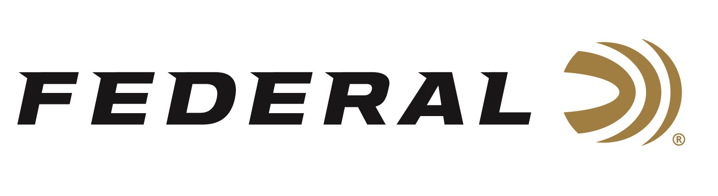

FOR IMMEDIATE RELEASE

Team Federal’s Kruse Sets New Texas State Championship Record

ANOKA, Minnesota – April 21, 2026 – Cory Kruse, Federal Ammunition’s newest team member, now stands alone in the record books at the Texas State Championship. Kruse won his 10th Texas resident sporting clay title, passing the previous record holder Bobby Fowler, who had nine belt buckles to his name. The Texas State Championships were held at the Defender Outdoors Clay Sports Ranch outside Fort Worth, Texas, April 14-19, 2026, and drew just over 900 shooters.

“It was a goal of mine for many years and I’ve worked hard for a long time for it,” said Kruse. “It takes a lot of time, effort and a massive support stream from my family and sponsors. I’m humbled and off the charts grateful for all who had a part in securing this new record,” continued Kruse. Kruse’s performance was good enough for third place in the Main Event Open High Over All title. “The target presentations were some of the best I’ve seen even with the tough wind and weather we fought,” said Kruse.

Team Federal’s Cameron Hicks continued his spring success with a High Over All win in the FITASC event. Hicks won the competition following a three-person shoot-off. Teammates Jonathan Prince, Gregg Wolf, and Cory Kruse all had a strong showing in FITASC with more than 300 shooters competing.

Team Federal’s young gun Jonathan Prince was the High Over All winner in the B&P Adios Cup. He was perfect in the 100-target event besting a field of 411 shooters. Other placings for Prince in the Junior Division include a Runner-Up finish in FITASC and a third place in Super Sporting.

In the “100 Ranch” Iron Man Event, Team Federal finished second, third, and fourth place with Hicks, Kruse, and Prince claiming those spots respectively.

Federal Ammunition products, including the new Master Class, are available at dealers nationwide and online. This competition-level sporting clay load features a customized Podium wad that extracts peak performance from utilizing Federal’s straight-wall hull, reliable primers, high-antimony lead shot, and select propellant. For more information on Master Class and all Federal products, visit www.federalpremium.com.

Federal Ammunition products are available at dealers nationwide and online. For more information on all Federal products and to sign up to receive notifications about new product availability, rebate promotions, and other brand news via email, visit www.federalpremium.com.

Press Release Contact: JJ Reich
Senior Manager – Press Relations
E-mail: media@tkghunt.com

About Federal Ammunition
Federal, headquartered in Anoka, MN, is an ammunition brand of The Kinetic Group, owned by CSG, a globally diversified industrial group based in Prague, Czech Republic. Since 1922, Federal has been a leader in ammunition innovation, delivering high-quality sporting and hunting products to shooters worldwide. With a commitment to conservation and the outdoor community, Federal continues to manufacture industry-leading ammunition that enhances the shooting experience while supporting outdoor traditions.

